Total Distance Travelled
Platform: LeetCode
Language: C
Module 1, Question 5

Problem Link
https://leetcode.com/problems/total-distance-traveled/description/

Problem Statement
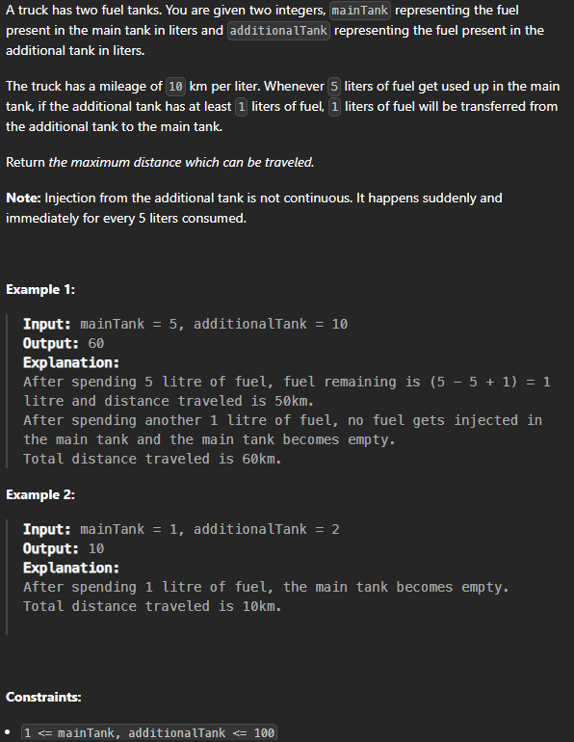

C Code
int distanceTraveled(int mainTank, int additionalTank) {
int dist = 0;
while (mainTank >= 5) {
mainTank -= 5; // use 5 litres
dist += 50; // 5 litres = 50 km
if (additionalTank > 0) { // transfer 1 litre from the additional tank
mainTank++;
additionalTank--;
}
}
return dist + mainTank * 10; // the remaining litres, at 10 km per litre
}

Screenshot of Successful Submission



